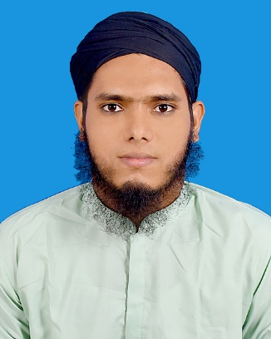

* Electrical installation and maintenance(Training running with certificate)
* Reading
* clubbing

**Hobbies**

* Cricket
* Football
* Internet browsing

# Professional Summary

**Duties/Responsibilities:**

* All plumbing UPVC/GI Pipe install by drawing.
* All HVAC, ductable ac install and cooling tower and chiller and AHU install (gas charging, vacuum test).
* Electrical wiring at Metro rail. BMS, LT cable install.
* Cable, CB, RCCB, BUS BAR selection.
* MDB, DB, SDB wiring and DOL, star-delta connection.
* EPP and MDB , ACPP,DG,ACP,WPP panel install.
* PF improvement and different panel install
* MLP, EACDB, RT Transformer install.
* Chiller sub –station install at suger mill.

**KEECO LIMITED** (Under Ezzy Automation ,ITALIAN THAI DEVEOLOPMENT) at DMTCL Project.

Adress:119/A ,Segun Bagicha ,Dhaka-1000

Web:WWW.Keecoltd.com

Pn: 01711665513

**01-01-21 -continue**

**1. SITE IN-CHARGE (MEP) ,Maintenance Engineer(ST13 to ST16 at CP06)**

**CAREER OBJECTIVE**

As a Electrical Engineer I want to get my job in my sector .Previous time I did it and at present also I am doing my job in my sector from my heart also loving. So have gathered knowledge now I want to execute my knowledge in your company and I know I can do Because of I am experience, skill, talent creativity, sincerity for the better achievement of the organization

An experienced engineer with a M.Sc. In Electrical and Electronic Engineering seeking employment in the electrical engineering sector, or any relevant field. With almost 3 years metro experience in Bangladesh first metro rail project with an extensive amount of previous experience in Telecommunication for 1.2 years. Still passionate about learning and consistently advancing my working knowledge and skill.

**EXPERIENCE**

**Extra Curricular Activities**

**Md. Torikul Islam**

aam

* HTML
* CSS
* JAVA SCRIPT(Basic)
* C Programing (Basic)
* Autocad (2D ,3D)
* PLC (Certified)
* Bangla
* English
* Hindi
* MS Word
* MS Power Point
* MS Excel
* Basic computer (certified)

M.Sc Engineer (EEE)

* **Phone :** 01791707968
* **Email :** [mdtorikulislam168@gmail.com](mailto:mdtorikulislam168@gmail.com)

**Programing Skills**

**Language**

**Skills**

**2. SYSTEM ENGINEER (MEP)**

Premium Technology Limited

Mohammadpur, sir Sayed Road,Dhaka-1216

**(02-11-2017 – 31th march 2018)**

**Duties/Responsibilities:**

* Complete Installation.
* Enable 4G Properly.
* Enable LTE properly.
* Submit Smart QC.
* Root.
* FE.
* 2G Installation

**Starlink Engineering limited**

Flat#1,House#83,Road#23,Gulshan,Dhaka-1212

Phone:+88029862208

Emaill:info@starlinkengineering.com

**(13th April,2018- November 2018)**

**Duties/Responsibilities:**

* Complete Installation.
* Enable 4G Properly.
* Enable LTE properly.
* Submit Smart QC.
* Root.
* FE.
* 2G Installation.

**3. SYSTEM ENGINEER (MEP)**

**Training of Electrical installation and Maintenance (01-3-24 to running)**

|  |  |
| --- | --- |
| Passing year: 2020M.sc in EEE, islamic university. CGPA : 3.42 out of 4.00 |  |
| Passing Year: 2017B.sc in EEE, varendra university. CGPA : 3.41 out of 4.00 Passing Year: 2013Science, Darshana Government College.Higher Secondary Certificate (HSC) Board : Jashore.  Result : 2.80 out of 5. **Passing Year: 2011****Science, Kotali Secondary School****Secondary School Certificate (SSC)**. Board : Jashore  Result : 3.94 out of 5 |  |

**EDUCATION**

Learning Engineering Institute

House-59, Block-G , Road-3, Bonosree, Rampura, Dhaka-1219 Bangladesh

Mobile: 01827516527

**Course Outline**

* House wiring.
* Industrial wiring.
* Switch board, SDB Board wiring.
* Electrical layout and conceal pipe install.
* Load calculation.
* Cable, CB Selection.
* Cable estimate.
* Earthing.
* Wiring inspection and testing.
* DOL wiring.
* LPS install.
* Automatic pump control by float less relay.
* MDB wiring, ATS.
* Star-delta, DOL starter connection.
* Motor forward reverse connection.
* Transformer.
* Sub-station, Overhead line.

I hereby declare that the above written particulars are true to the best of my knowledge and belief.

SIGNATURE

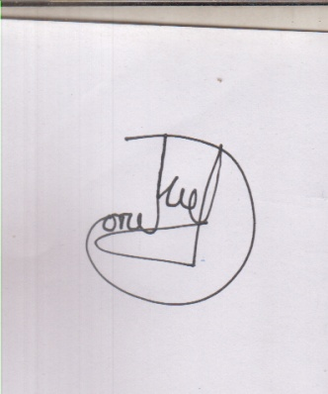

MD: Torikul Islam

**Muhammad SajjadurRahim**

Associate Professor

Department of Information and

Communication Engineering

University of Rajshahi

Email: [sajid_ice@ru.ac.bd](mailto:sajid_ice@ru.ac.bd)

Mobile:+8801721516550

&

Coordinator

**Professor Dr. M. OsmanGaniTalukder**

Vice Chancellor

Varendra University

Kazla, Mothihar, Rajshahi-6204

Tel:(0721) 750359, 751274

Fax: (0721) 750748

Cell: 01730-406506

Email:vc@vu.edu.com

Web:www.vu.edu

# Reference

Name : Md. Torikul Islam

Father’s Name : Md. Munjil Hossan

Mother’s Name : Most. MoriomKhatun

Sex : Male.

Date of Birth : 17-10-1996

Religion : Islam

Marital Status : Unmarried.

Nationality : Bangladeshi (By birth).

Blood Group : A(+)

**PERSONAL INFORMATION**